MMA LAB
Book :- 8086 douglas hall book :- https://toaz.info/doc-view-4
LCA 1: 1, 2, 4
LCA 2: 3, 5, 6, 7
LCA 3: 8, 9

Evolutionary Eras of Microprocessor Technology
1. Era 1: 1971–1972
- Primary Chips: Intel 4004 and the 8008.
- Summary: Marking the debut of commercial microprocessing, the Intel 4004 utilized 2,300 transistors for 4-bit calculator operations. Its successor, the 8008, provided 8-bit capabilities.
2. Era 2: 1973–1978
- Primary Chips: Intel 8080, Motorola 6800, and Zilog Z80.
- Summary: Adoption of NMOS technology facilitated faster execution for these 8-bit devices, supporting the rise of early computing hardware like the Altair 8800.
3. Era 3: 1978–1984
- Primary Chips: Intel 8086, 8088, and Motorola 68000.
- Summary: Initiated 16-bit processing; the 8086 established the enduring x86 standard. Key innovations included instruction pipelining and expanded memory access.
4. Era 4: 1985–1994
- Primary Chips: Intel 80386, 80486, and the Pentium series.
- Summary: Transitioned to 32-bit computing to enable multitasking and sophisticated graphics. This generation integrated dedicated math coprocessors for high-end multimedia tasks.
5. Era 5: 1995–Present
- Primary Chips: Intel Core, AMD Ryzen, and Apple Silicon.
- Summary: Modern 64-bit multi-core designs utilize billions of transistors for AI and heavy workloads. Current systems prioritize virtualization, cache efficiency, and advanced power management.

Category | iOS | Android
Environment | Requires Apple hardware to run Xcode. | Android Studio runs on macOS, Windows, or Linux.
Languages | Swift | Kotlin
UI Frameworks | SwiftUI (Human Interface Guidelines) | Jetpack Compose (Material Design)
Testing Complexity | Highly predictable; few devices to target. | Heavy fragmentation; hundreds of screen sizes and hardware specs.
App Store Approval | Strict review process; can take several days. | Typically faster (hours). New accounts require 20 testers for 14 days.
Developer Fees | $99/year membership fee | One-time $25 registration fee

Feature | Apple M-Series | Intel
Architecture | Integrates the CPU, GPU, and RAM into a single Unified Memory pool. | Generally keep components separate across the motherboard.
Power & Battery | Significantly more power-efficient; massive battery life and stays very quiet under load. | Can run hot and consume much more battery, especially on older Macs.
Performance | Dominates the laptop market in power efficiency. | High-end desktop chips can drawing massive power to edge out Apple on multi-threaded tasks.
Software Compatibility | Uses custom ARM chips; requires apps to be updated or use Rosetta 2; no native Windows Boot Camp. | Natively runs Windows and a wider variety of legacy software.

What is 8086 Instruction Set?
The 8086 instruction set is a group of commands that the Intel 8086 microprocessor uses to perform tasks. It includes a variety of instructions that allow developers to create software for many different tasks, from simple math to more complex processing. Understanding this instruction set is essential for anyone looking to work with the 8086 microprocessor and its applications.

Data Transfer: MOV AX, BX :-
Copies the contents of the source register (BX) into the target register (AX).

Arithmetic: ADD AX, BX :-
Includes arithmetic operations such as summation, subtraction, and handling carry or borrow flags.

Logical Operation: OR :-
Bitwise logical operations.

Control Transfer: JNC next/label :-
Instruction to branch if the carry flag is clear.
When CF = 0: No carry or borrow occurred. The CPU redirects execution to the specified memory address or label.
When CF = 1: A carry or borrow exists. Execution continues sequentially, bypassing the jump instruction.

https://www.geeksforgeeks.org/electronics-engineering/8086-instruction-set/

Code :-

MOV AX, 0005H ; Load 0005 into AX
ADD AX, FFF0H ; AX = AX + FFF0H (generates a carry)
JNC NO_CARRY ; If CF = 0, jump to NO_CARRY
; --- Code here executes if Carry = 1 ---
JMP END ; Skip to end
NO_CARRY:
; --- Code here executes if Carry = 0 ---
END:

Egs :-
AX = 0FH
BX = 04H

Bursts
Multiplexers
Conversions

Assembly code printf and input

Section .data

msg db 10, "Good Morning"
msg_len equ $-msg

mymsg db 10, "Everyone"
mymsg_len equ $-mymsg

Section .bss

arr resd 10
arr_len equ $-arr

Section .text
global _start

_start:
mov rax, 0
mov rdi, 0
mov rsi, arr
mov rdx, 16
syscall

mov rax, 1
mov rdi, 1
mov rsi, msg
mov rdx, msg_len
syscall

mov rax, 1
mov rdi, 1
mov rsi, mymsg
mov rdx, mymsg_len
syscall

mov rax, 1
mov rdi, 1
mov rsi, arr
mov rdx, arr_len
syscall

mov rax, 60
mov rdi, 0
syscall

Assembly Code Execution workflow

Commands

To Assemble -
nasam -f elf64 first.asm
To Link -
ld -0 first first.o
To execute -
./first

-f implies ‘file format’ for the object file.
Default file format of nasam is “bin” i.e binary.

(;) is for comments

ALP Program Structure

Section .data ; declare data segment
; initialized variable Declaration

Section .bss ; declare block started by segment sort of Extra Data Segment
; uninitialized variable declaration

Section .text ; declare code segment
global _start ; entry point for program
_start:

; program code goes here

Assembler directive and Instructions diff?

Above part is assembler directives

After section there is space

Section .data ; initialized variable declaration

Syntax: Var_Name Data_Type Variable_Value

Ex: A db 50

Data Type | Definition | Size
DB | Define/Declare Byte | 8 bit
DW | Define/Declare Word | 16 bit
DD | Define/Declare Double Word | 32 bit
DQ | Define/Declare Quad Word | 64 bit

Eg: msg db 10, “The sum of array elements is:”

msg_len equ $-msg ;this calculates length msg and assigns var msg_len

Section .Bss ;Uninitialized variable declaration

Syntax: Var_Name RES memory_type memory size

Eg: A resb 50 -> stands for 50 locations of bytes for A

RES - Reserve Memory Types

Data Type | Definition | Size
RESB | Reserve Byte | 8 bit
RESW | Reserve Word | 16 bit
RESD | Reserve Double Word | 32 bit
RESQ | Reserve Quad Word | 64 bit

Section .text ; code of the program

It always starts with

global _start ; (Entry point for the program)
_start:

System write/output Call (64 bit)
Display variable_name contents of specified variable length on monitor

mov rax, 1 ; function number for writing/outputting data

mov rdi, 1 ; file descriptor id for standard output device (monitor)

mov rsi, hello ; starting address of the string to be displayed

mov rdx, helloLen ; number of bytes to be displayed

Syscall ; system call (inbuilt function)

System Exit call (64 bit)
Function to exit or terminate a program

mov rax, 60 ; function number for sys-exit
mov rdi, 0 ; return code for zero error
Syscall
By vip bam:-

Asambler convert to machin language
msg db "Hello, World!",10
Msg -> variable name
Db - data bit
0AH -> hex value(ig null)
10 -> next line
Msglen -> for len
Equ -> = (this will mae msglen const, and const don’t take space)
$ - msg -> pointed

Section .bss -> use to allocate space
Name resb-30 -> to store the name
Temp resb 1

Section .text
Global _start -> viable in whole code
_start -> to start

Mov rax, 1 -> 1 will store in rax. Write option
Rsi -> to locate the address

Rax, 0 -> to read
Rsi, -> to store the entered data it is of 30 bit

.asm for this code!

System Call | Number
read | 0
write | 1
exit | 60

EXP-1

section .data

a db 10, 'hello world' ,10
alen equ $-a

num_array db 01h,02h,03h,01h,05h

hi db 10, 'result of array addition is: '
hilen equ $-hi

section .bss

result resw 1
temp resw 2
temp1 resb 1

%macro rw 4

mov rax, %1
mov rdi, %2
mov rsi, %3
mov rdx, %4
syscall

%endmacro

section .text

global _start

_start:

mov rax, 1
mov rdi, 1
mov rsi, a
mov rdx, alen
syscall

mov rsi, num_array
mov ax, 00h
mov bx, 0h
mov cx, 5

up2: mov bl, byte[rsi]
add ax, bx
jnc skip
inc ah

skip:
inc rsi
dec cx
jnz up2

mov word[result], ax

mov ax, word[result]
mov bp, 4

up:rol ax, 4
mov bx, ax
and ax, 0Fh
cmp al, 09
jbe down
add al, 07h
down: add al, 30h
mov byte[temp], al
rw 1,1,temp,1
mov ax, bx
dec bp
jnz up

mov rax, 1
mov rdi, 1
mov rsi, hi
mov rdx, hilen
syscall

rw 60,0,0,0

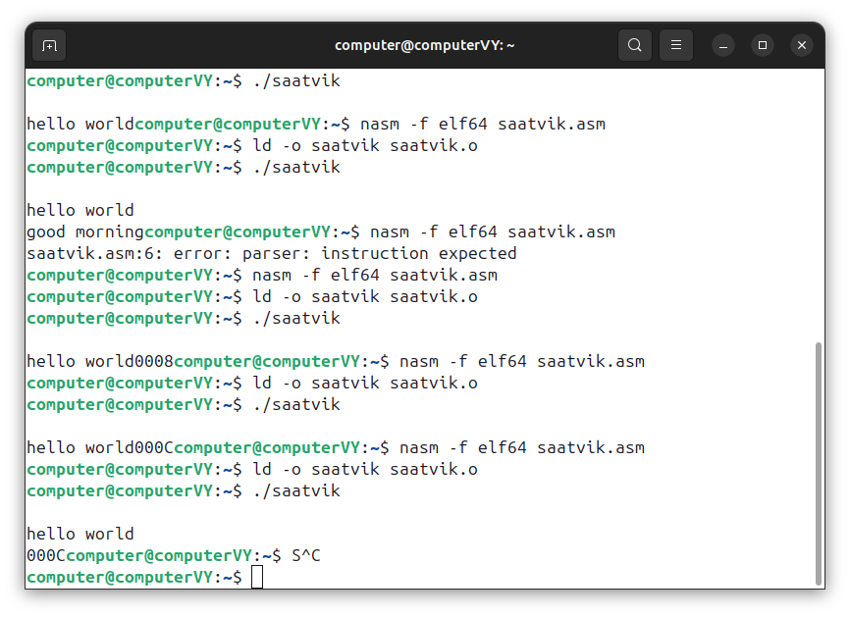

VIP BAM :- code

section .data
a db 02h
b db 03h
temp db 0

%macro read 4
mov rax, %1
mov rdi, %2
mov rsi, %3
mov rdx, %4
syscall
%endmacro

section .text
global _start

_start:

mov al, [a]
mov bl, [b]
add al, bl

mov bp, 4
up:rol ax, 4
mov bx, ax
and ax, 0Fh
cmp al, 09
jbe down
add al, 07h
down: add al, 30h
mov byte[temp], al
read 1,1,temp,1
mov ax, bx
dec bp
jnz up

read 60,0,0,0

0 0 0 0 0 1 0 1

0 1 0 1 0 0 0 0
& 0 0 0 0 1 1 1 1
0 0 0 0 0 0 0 0

3132 - 30, 3a3b - 37

